Dear Parent or Guardian:

We are pleased to offer the PowerSchool Parent Portal! With this portal, parents and guardians have access to their student’s grades and attendance. Parent and guardians do not need to share logins, as each parent or guardian can set up his or her own unique login and password. Please follow the directions below to get started using the PowerSchool Parent Portal.

- Go to the “PowerSchool Parent Portal” log in page:
www.nfschools.net then click on the Parent Portal (A+) at the top right.

- Choose Create Account
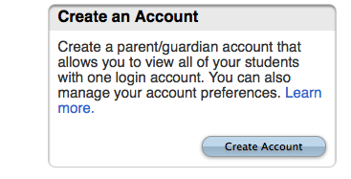

- At the top of the screen fill in your information including new password, which must be at least 6 characters.

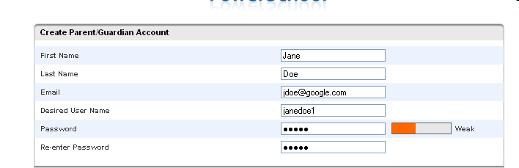

First Name – Enter your first name.
Last Name – Enter your last name.
Email – Enter your email address.
Desired User Name – Enter the user name you would like to use when logging into the PowerSchool Parent Portal. The user name must be unique. If you enter a user name that is already in use, you will be prompted to select or enter another user name.
Password – Must be a minimum of 6 characters. When entering your password, a
colored bar will appear to the right – this indicates the strength of the password.
The more color that fills up the bar, the stronger the password.
Re-enter Password – Re-enter your password. The password you enter must match the Password field.
- At the bottom of the screen enter the Student Name, Access ID, Access Password, and choose a relationship to link your student(s) to your new login. If you have more than one student you can enter all of their names, Access IDs, and Access Passwords on this page. Once all information has been entered click enter. Access IDS and Passwords can be obtained from your child’s school secretary.

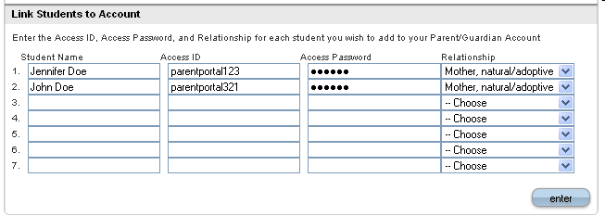

Once you click enter you will be taken to the Parent Portal log in screen and should see the following:
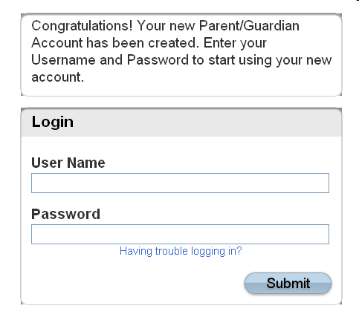
You can now log into the Parent Portal using the User Name and Password you created. Once you are logged into the Parent Portal you can manage your account by clicking the Account Preferences button. If you have more than one student, you will see buttons to switch between your student’s information.
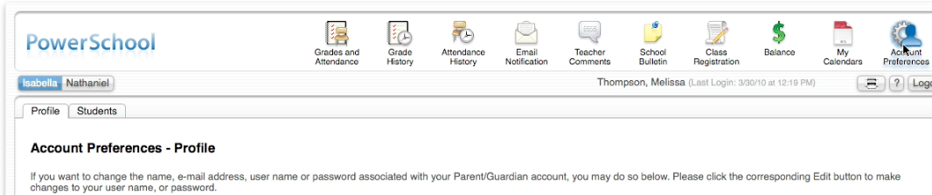

Additionally, PowerSchool is available through an app. The app icon looks like this: 
You will need the District Code, which is BQRR.

